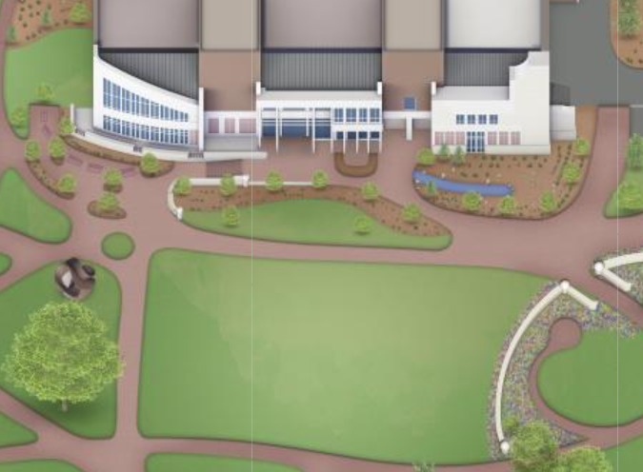

6 ft rounds

Churros

Pretzels and corndogs

Ice cream bar

Slide

Golden hour backdrop

Carnival games